Cisco 3725的配置
show run
Building configuration...

Current configuration : 3620 bytes
!
version 12.4
service timestamps debug datetime msec
service timestamps log datetime msec
no service password-encryption
!
hostname VPN_Central 在前段使用FQDN的对端标示类型时添加这句话
!
boot-start-marker
boot-end-marker
!
enable password cisco
!
no aaa new-model
clock timezone GMT 0
ip cef
!
!
ip auth-proxy max-nodata-conns 3
ip admission max-nodata-conns 3
!
!
no ip domain lookup
ip domain name cisco.com 在前段使用FQDN的对端标示类型时添加这句话
!
!
!
crypto isakmp policy 1
encr 3des
hash md5
authentication pre-share
group 2
lifetime 3600
crypto isakmp key cisco123 address 0.0.0.0 0.0.0.0
crypto isakmp identity hostname
!
!
crypto ipsec transform-set rtpset esp-3des esp-md5-hmac
!
crypto dynamic-map rtpmap 10
set transform-set rtpset
match address 115
!
!
crypto map rtptrans 10 ipsec-isakmp dynamic rtpmap
!
!
!

interface FastEthernet0/0
ip address 10.11.230.177 255.255.255.240
no ip redirects
no ip proxy-arp
duplex auto
speed auto
crypto map rtptrans
!
interface FastEthernet0/1
ip address 10.11.230.174 255.255.255.240
no ip redirects
no ip proxy-arp
duplex auto
speed auto
!
ip default-gateway 10.11.230.129
ip forward-protocol nd
ip route 0.0.0.0 0.0.0.0 10.11.230.178
!
no ip http server
ip http access-class 22
ip http secure-server
!
access-list 10 permit 192.168.2.111
access-list 22 permit 192.168.1.126
access-list 115 permit ip 172.16.0.0 0.0.255.255 192.168.2.0 0.0.0.255
access-list 115 permit ip 10.10.10.0 0.0.0.255 192.168.2.0 0.0.0.255
access-list 115 permit ip 10.11.230.160 0.0.0.15 192.168.2.0 0.0.0.255
arp 10.11.230.167 001b.7839.dd90 ARPA
arp 10.11.230.164 001b.7839.db78 ARPA
arp 10.11.230.178 000f.e265.23d1 ARPA
route-map nonat permit 10
match ip address 120
!
!
!
control-plane
!
!
!
line con 0
line aux 0
line vty 0 4
password 123456
login
!
! end

TD 路由器的VPN配置

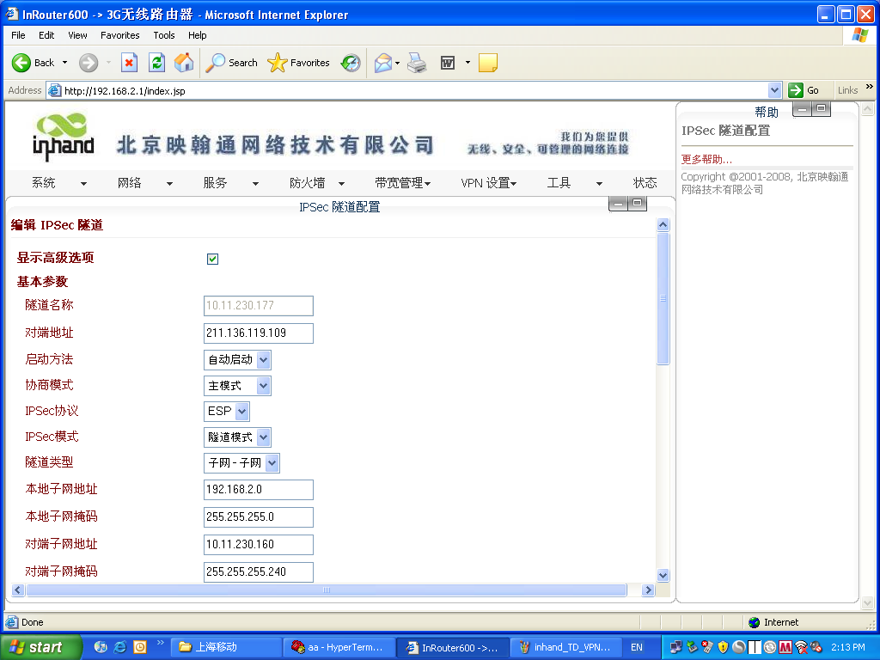
其中的对端地址就是cisco路由器的公网Ip，本地Ip就是无线路由器的局域网地址段，对端IP就是cisco路由器内网下的地址段
注：根据实际情况改Ip，其他配置不要动

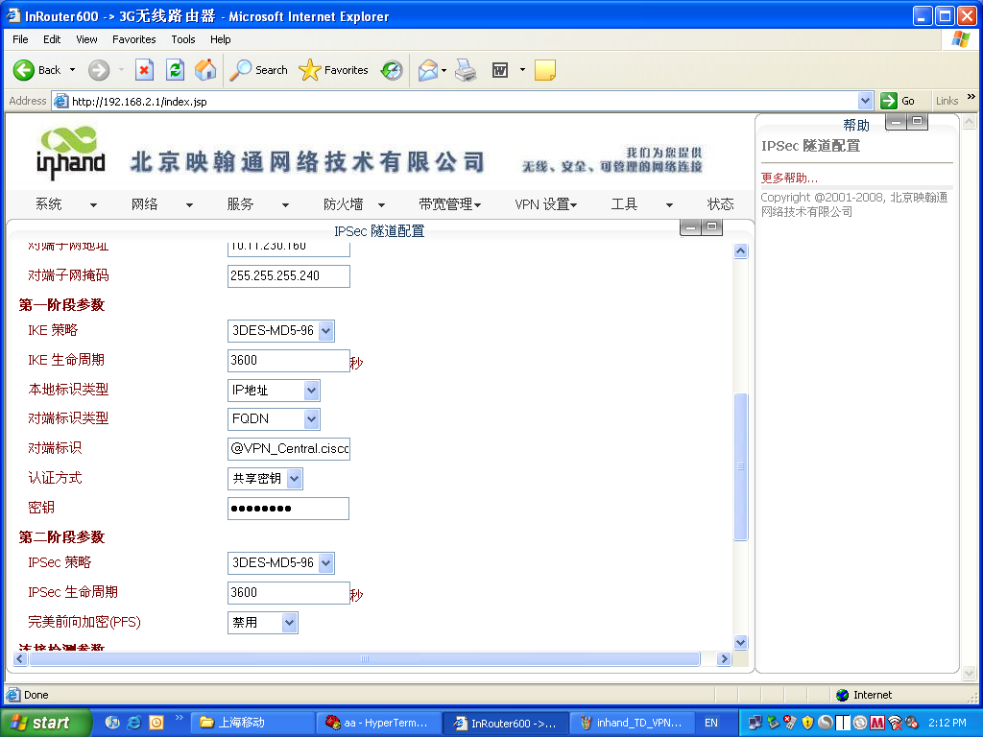
其中的对端标示（@VPN_Central.cisco.com）就是我在cisco里表明的配置相一致的
hostname VPN_Central 在前段使用FQDN的对端标示类型时添加这句话
ip domain name cisco.com 在前段使用FQDN的对端标示类型时添加这句话
其他照搬

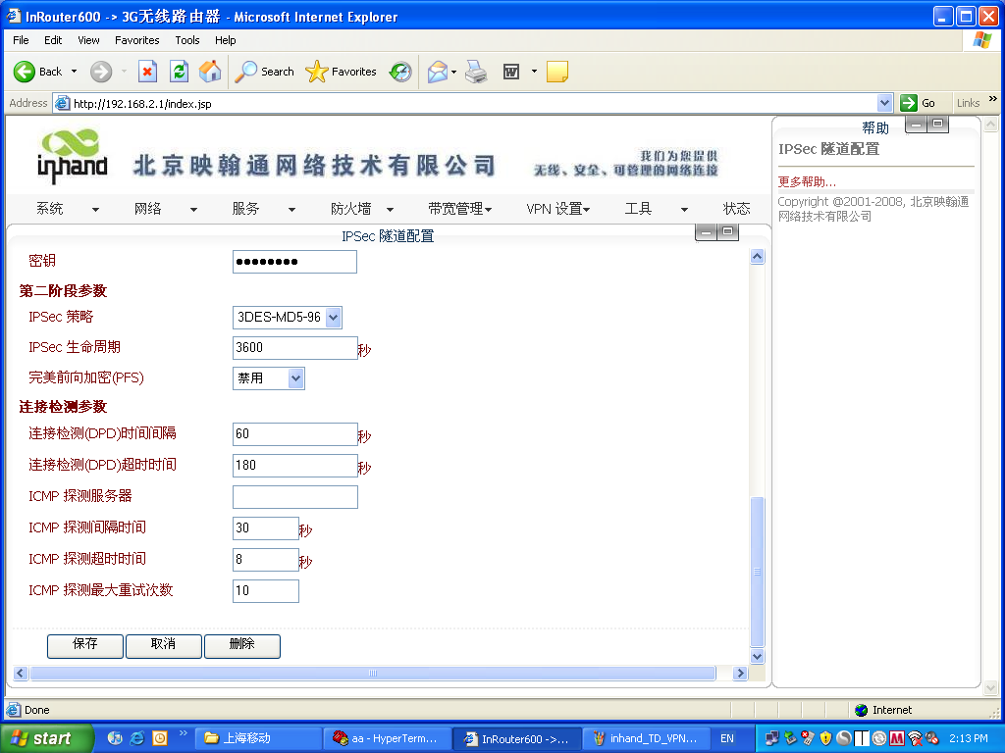
其中的密钥要和cisco里配的一致，即这里我配得就是cisco123
crypto isakmp key cisco123 address 0.0.0.0 0.0.0.0
其他照搬

